(Restorative Dentistry and Endodontics: Case Report)
Multidisciplinary management of invasive cervical resorption using bioceramic materials and injectable composite guided by CBCT: a case report
Fani Pangabdian,^{1,*} Aprilia,¹ Diana Soesilo,¹ Eddy Hermanto,² Sarianoferni³
1Department of Conservative Dentistry, Faculty of Dentistry, Universitas Hang Tuah, Surabaya, Indonesia
2Department of Oral and Maxillofacial Surgery, Faculty of Dentistry, Universitas Hang Tuah, Surabaya, Indonesia
3Department of Oral and Maxillofacial Radiology, Faculty of Dentistry, Universitas Hang Tuah, Surabaya, Indonesia
Running Title: Invasive cervical resorption management
Pangabdian F, Aprilia, Soesilo D, Hermanto E, Sarianoferni.
*Correspondence: Fani Pangabdian
Department of Conservative Dentistry, Faculty of Dentistry, Universitas Hang Tuah, Jln. Arief Rachman Hakim No. 150, Surabaya 60111, Indonesia
E-mail: fani.pangabdian@hangtuah.ac.id, Tel: +62-817-386-917

ORCID
Fani Pangabdian https://orcid.org/0000-0002-1183-2043
Aprilia https://orcid.org/0000-0003-1518-292X
Diana Soesilo https://orcid.org/0000-0003-4584-6694
Eddy Hermanto https://orcid.org/0009-0008-3658-4710
Sarianoferni https://orcid.org/0000-0002-2904-3106

Funding
No funding was received for this case report.

Data availability statement
Data sharing is not relevant because no datasets were created and/or analyzed for this case report. Clinical information is presented in de-identified form in the manuscript and figures.

Ethics statement
Written informed consent was obtained from the patient for treatment and for publication of this case report and the accompanying clinical and radiographic images. The case information was prepared in de-identified form.

ABSTRACT
Invasive cervical resorption is an external resorptive lesion that may remain clinically silent until substantial loss of dental hard tissue has occurred. This case report describes the multidisciplinary management of Heithersay Class III invasive cervical resorption affecting the left maxillary central incisor of a 35-year-old female with a history of dental trauma and fixed orthodontic treatment. Clinical examination revealed cervical discoloration, bleeding on probing, percussion and palpation sensitivity, and loss of pulpal vitality. Periapical radiography and cone-beam computed tomography confirmed an irregular cervical resorptive defect extending toward the pulp and into the coronal third of the root, with buccal cortical thinning. Management consisted of root canal treatment with gutta-percha and a bioceramic sealer, surgical flap access, curettage of resorptive tissue, disinfection, defect repair with mineral trioxide aggregate, and subsequent cervical restoration using injectable composite. At six months, the tooth remained asymptomatic, gingival tissues were healthy, and radiographic findings showed no periapical pathology. This case highlights the importance of three-dimensional diagnosis, biocompatible repair materials, and coordinated endodontic, surgical, radiologic, and restorative decision-making in preserving teeth affected by advanced invasive cervical resorption.
Keywords: Cone-Beam Computed Tomography; Dental Materials; Mineral Trioxide Aggregate; Root Canal Therapy; Tooth Resorption

INTRODUCTION
Root resorption is a pathologic loss of dental hard tissue that may involve cementum, dentin, and root structure. It may progress to tooth loss when the condition is not diagnosed and treated at an appropriate stage [1]. Root resorption is generally classified as internal or external according to its site of initiation. Internal resorption begins within the pulp chamber or root canal system, whereas external resorption starts from the external root surface and may subsequently approach the pulp space [2].
Invasive cervical resorption (ICR) is a distinct form of external resorption that begins in the cervical region of the tooth, usually close to the cemento-enamel junction. It has a progressive and destructive nature and may be mistaken for cervical caries in its early stages because clinical signs are often limited or absent [1,3]. Heithersay classified ICR into four classes according to the extent of the lesion, ranging from a small superficial lesion to extensive resorption extending beyond the coronal third of the root [4,5].
The etiology of ICR is multifactorial. Predisposing factors reported in the literature include dental trauma, orthodontic treatment, internal bleaching, periodontal surgery, deep cervical restorations, and previous endodontic treatment [6]. Clinically, ICR can present as a pinkish discoloration in the cervical region, bleeding on probing, or an incidental radiographic finding. Pulp vitality may be preserved in early lesions, and vitality testing is therefore important to distinguish ICR from internal resorption, cervical caries, root fracture, and combined endodontic-periodontal lesions [7].
Radiographic diagnosis using conventional two-dimensional imaging can be limited because the true extension of the defect, its relationship to the pulp, and the condition of the surrounding cortical plate may not be fully visible. Cone-beam computed tomography (CBCT) improves diagnostic accuracy by providing three-dimensional assessment of lesion location, size, and structural involvement [4,8]. This case report describes the CBCT-guided multidisciplinary management of Heithersay Class III ICR in a maxillary central incisor using endodontic treatment, surgical repair with mineral trioxide aggregate (MTA), and esthetic restoration with injectable composite.
CASE REPORT(S)
A 35-year-old female patient presented to RSGM Nala Husada with a chief complaint of a reddish swelling in the upper left anterior gingival region. The patient reported a history of trauma to the same region four years earlier, followed by fixed orthodontic treatment. The initial pain had gradually subsided. Clinical examination of tooth 21 showed discoloration on the labial cervical surface. A catch was detected during probing and was accompanied by bleeding. The tooth was sensitive to percussion and palpation, and pulp vitality testing indicated a non-vital response (Figure 1). Written informed consent was obtained from the patient before treatment and for publication of the case and clinical images.
Periapical radiography showed an irregular radiolucent lesion with a mottled appearance involving enamel and dentin and extending close to the pulp. The lesion reached the coronal one-third of the root and was therefore diagnosed as Heithersay Class III ICR on two-dimensional assessment. CBCT examination provided a more detailed visualization and confirmed a radiolucent defect invading enamel and dentin, approaching the pulp space, and associated with thinning of the buccal cortical plate (Figure 2A-2C).
Root canal treatment was performed under rubber dam isolation. Access was prepared through the palatal aspect, and the working length was determined with an apex locator and confirmed radiographically. A glide path was established using a #10 K-file, followed by rotary instrumentation up to size F3. Irrigation was performed using 2.5% sodium hypochlorite (NaOCl) and 17% ethylenediaminetetraacetic acid at each instrument change. Calcium hydroxide was placed as an intracanal medicament for 14 days. At the next visit, the canal was obturated with gutta-percha and a bioceramic sealer before surgical repair (Figure 3).
Surgical management was performed under local anesthesia. A full-thickness mucoperiosteal flap was raised on the labial side to obtain direct access to the resorptive defect. After flap reflection, granulomatous tissue extending from the labial surface toward the cervical third of the crown was identified. The resorptive tissue was carefully curetted until bleeding was controlled. The defect was disinfected with 5.25% NaOCl and repaired using MTA according to the manufacturer’s instructions. The flap was then repositioned (Figure 4A and 4B).
Four weeks after the surgical procedure, the patient was recalled for evaluation of soft-tissue healing. The cervical region was restored with injectable composite to re-establish contour and esthetics. At the six-month follow-up, the tooth was asymptomatic. The gingiva appeared healthy, and no pathologic periodontal findings were observed. Radiographic evaluation showed favorable healing with no periapical abnormality and healthy surrounding bone conditions (Figure 5A and 5B).
DISCUSSION
Treatment planning for ICR depends primarily on the severity and extent of the lesion. The principal objective is to arrest the resorptive process by removing resorptive tissue and restoring the defect with a biocompatible material [1,9]. In the present case, the lesion was diagnosed as Heithersay Class III because it extended into the coronal third of the root. A combined endodontic and surgical approach was therefore selected to manage the non-vital pulp, allow direct visualization of the subgingival defect, and provide adequate repair [9].
The pathogenesis of ICR is thought to begin with damage to the cervical cementum and exposure of dentin, which permits colonization by clastic cells from periodontal tissues [5,10]. Granulation tissue can then proliferate and allow the lesion to expand laterally and apically within dentin [7]. In this patient, the previous trauma and orthodontic treatment were considered relevant predisposing factors because both have been associated with external cervical resorption [6].
Accurate diagnosis is a critical determinant of treatment success. Conventional radiography helped identify the cervical radiolucency, but CBCT clarified the three-dimensional extent of the defect, its proximity to the pulp, and the thinning of the buccal cortical plate. This information influenced both the endodontic and surgical phases of treatment. CBCT is particularly useful in ICR because it allows differentiation from internal resorption and assists in determining whether the tooth can be maintained [11].
MTA was selected to repair the resorptive defect because of its biocompatibility, sealing ability, and suitability for irregular defects close to periodontal tissues [7,12]. The material may also support hard-tissue repair and periodontal healing when placed in contact with surrounding tissues. A bioceramic sealer was used during obturation to improve sealing of the root canal system and reduce microleakage. Bioceramic materials exhibit favorable dimensional stability during setting, which is advantageous for maintaining the long-term seal of endodontically treated teeth [8].
Injectable composite was used for the cervical restoration after soft-tissue healing because the defect location required favorable adaptation, esthetic integration, and conservative placement. Compared with conventional low-filled flowable materials, highly filled injectable composites can provide improved handling and mechanical properties in cervical restorations requiring both function and esthetics [12].
The favorable six-month outcome in this case was indicated by the absence of symptoms, healthy gingival tissues, and no radiographic evidence of periapical pathology. However, ICR may recur or progress slowly, and longer follow-up remains necessary. The main limitation of this report is that it describes a single clinical case with a relatively short follow-up period. Nevertheless, the case demonstrates that a coordinated multidisciplinary approach can preserve a tooth with advanced cervical resorption when diagnosis, access, debridement, material selection, and coronal restoration are carefully integrated.
CONCLUSIONS
CBCT-guided diagnosis and treatment planning were essential for identifying the extent of Heithersay Class III invasive cervical resorption in this maxillary central incisor. A multidisciplinary approach involving root canal treatment, surgical debridement, MTA repair, and injectable composite restoration resulted in favorable clinical and radiographic findings at six months. Long-term monitoring is required, but this case supports the clinical value of combining three-dimensional imaging, biocompatible repair materials, and minimally invasive restorative management for tooth preservation in advanced ICR.
Author Contributions
Conceptualization: Pangabdian F, Soesilo D. Data curation: Pangabdian F, Aprilia, Sarianoferni. Formal analysis: Pangabdian F, Soesilo D, Sarianoferni. Funding acquisition: not applicable. Investigation: Pangabdian F, Aprilia, Hermanto E, Sarianoferni. Methodology: Pangabdian F, Aprilia, Soesilo D, Hermanto E. Project administration: Pangabdian F. Resources: Pangabdian F, Hermanto E, Sarianoferni. Software: not applicable. Supervision: Soesilo D. Validation: Pangabdian F, Aprilia, Soesilo D, Hermanto E, Sarianoferni. Visualization: Pangabdian F, Hermanto E, Sarianoferni. Writing - original draft: Pangabdian F, Aprilia. Writing - review & editing: Pangabdian F, Aprilia, Soesilo D, Hermanto E, Sarianoferni.
CONFLICT OF INTEREST
No potential conflict of interest relevant to this article was reported.
ACKNOWLEDGEMENTS
The authors would like to thank Universitas Hang Tuah and RSGM Nala Husada for their support during the preparation of this case report.
ORCID
Fani Pangabdian https://orcid.org/0000-0002-1183-2043
Aprilia https://orcid.org/0000-0003-1518-292X
Diana Soesilo https://orcid.org/0000-0003-4584-6694
Eddy Hermanto https://orcid.org/0009-0008-3658-4710
Sarianoferni https://orcid.org/0000-0002-2904-3106

REFERENCES
- Nireeksha BN, Harsha P, Naik BD, Setty S, Horatti P. Management of invasive external cervical resorption in maxillary anterior teeth: a case report. J Restor Dent Endod 2022;1:63-66.
- Garg N, Garg A. Textbook of endodontics. 4th ed. New Delhi: Jaypee Brothers Medical Publishers; 2022.
- da Cunha Isaltino M, da Silva Souza C, de Oliveira NG, de Melo Junior PM, Velozo Telles CT, de Albuquerque DS. Endodontic and surgical management of an invasive cervical resorption in a maxillary central incisor: a case report. Iran Endod J 2023;18:168-173.
- Ghabraei S, Bolhari B, Hashemi N, Gharehchahi H. Conservative management of an advanced external cervical resorption with internal approach using bio-ceramic materials: a case report. Clin Case Rep 2024;12:e8378.
- Howait M, Shaker M, Aljuhani H, AlMohnna M. External cervical resorption: a case report and brief review of the literature, and treatment algorithms. J Contemp Dent Pract 2021;22:298-303.
- Chen Y, Huang Y, Deng X. External cervical resorption-a review of pathogenesis and potential predisposing factors. Int J Oral Sci 2021;13:19.
- Lin Y, Thumbigere-Math V, Kishen A, He J. Unraveling the etiology and pathogenesis of multiple cervical root resorption - a scoping review. J Endod 2025. doi: 10.1016/j.joen.2025.02.012.
- Bardini G, Orru C, Ideo F, Nagendrababu V, Dummer P, Cotti E. Clinical management of external cervical resorption: a systematic review. Aust Endod J 2023;49:769-787.
- Mount GJ, Hume WR, Ngo HC, Wolff MS, editors. Preservation and restoration of tooth structure. 3rd ed. New York: John Wiley & Sons; 2016.
- Ritter AV, Boushell LW, Walter R. Sturdevant's art and science of operative dentistry. 7th ed. St. Louis: Elsevier; 2019.
- Torabinejad M, Fouad AF, Shabahang S. Endodontics: principles and practice. 6th ed. St. Louis: Elsevier; 2021.
- Stefanac SJ, Nesbit SP. Diagnosis and treatment planning in dentistry. 3rd ed. St. Louis: Elsevier; 2017.

FIGURE LEGENDS
Figure 1. Preoperative clinical photograph showing cervical discoloration and swelling in the maxillary left anterior region associated with tooth 21.
Figure 2. Preoperative radiographic and cone-beam computed tomography findings. (A) Periapical radiograph showing an irregular radiolucent cervical lesion. (B) Axial cone-beam computed tomography section of tooth 21. (C) Sagittal cone-beam computed tomography section showing the extent of the resorptive defect and buccal cortical thinning.
Figure 3. Periapical radiograph of tooth 21 after root canal treatment.
Figure 4. Surgical management of the invasive cervical resorption defect. (A) Full-thickness flap reflection and exposure of the resorptive defect. (B) Repair of the defect using mineral trioxide aggregate.
Figure 5. Six-month follow-up findings. (A) Periapical radiograph showing absence of periapical pathology. (B) Clinical photograph showing healthy gingival tissues and esthetic restoration.

FIGURES
Figure 1.
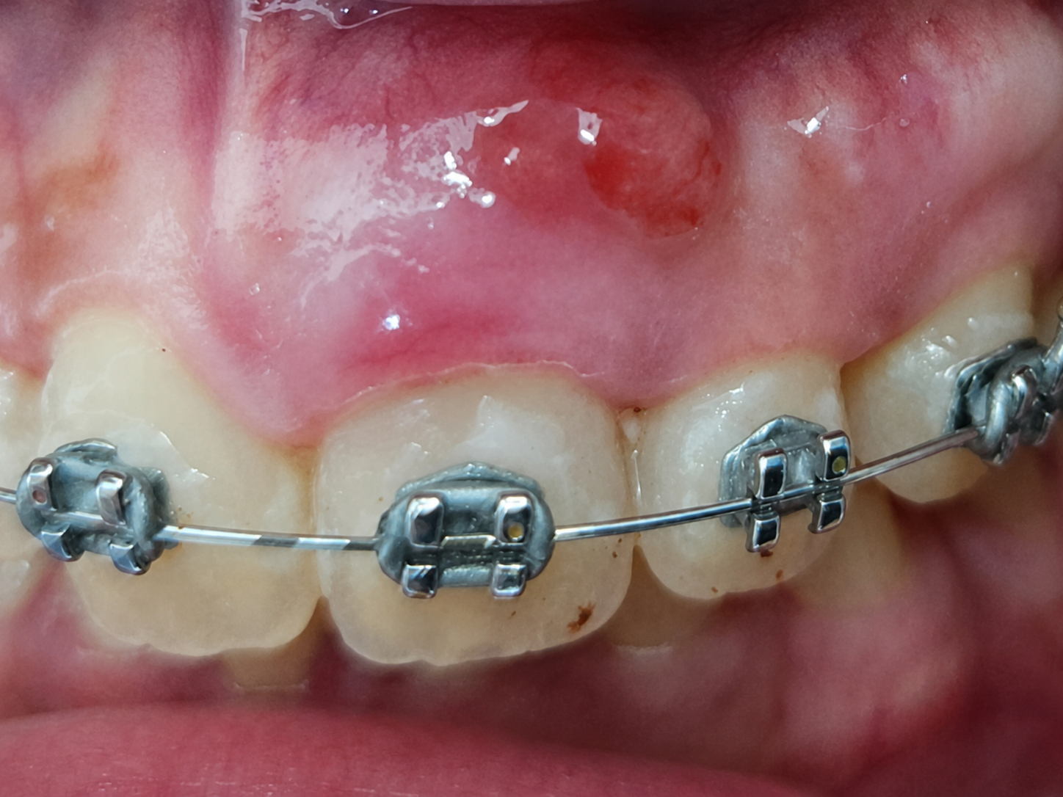

Figure 2.

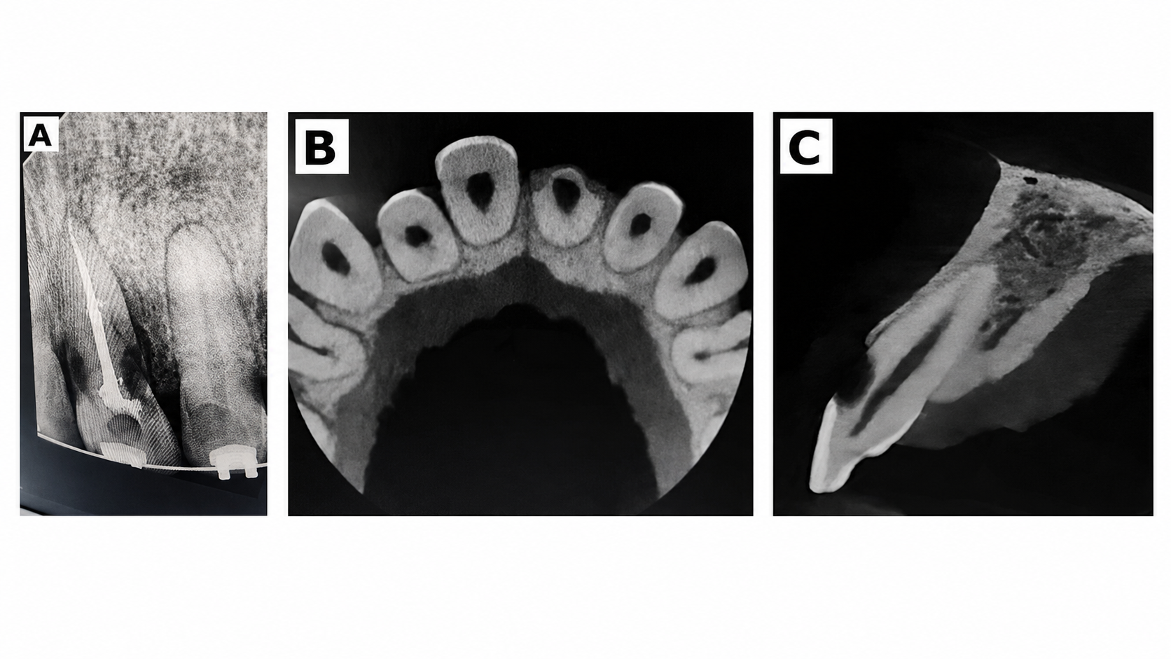

Figure 3.
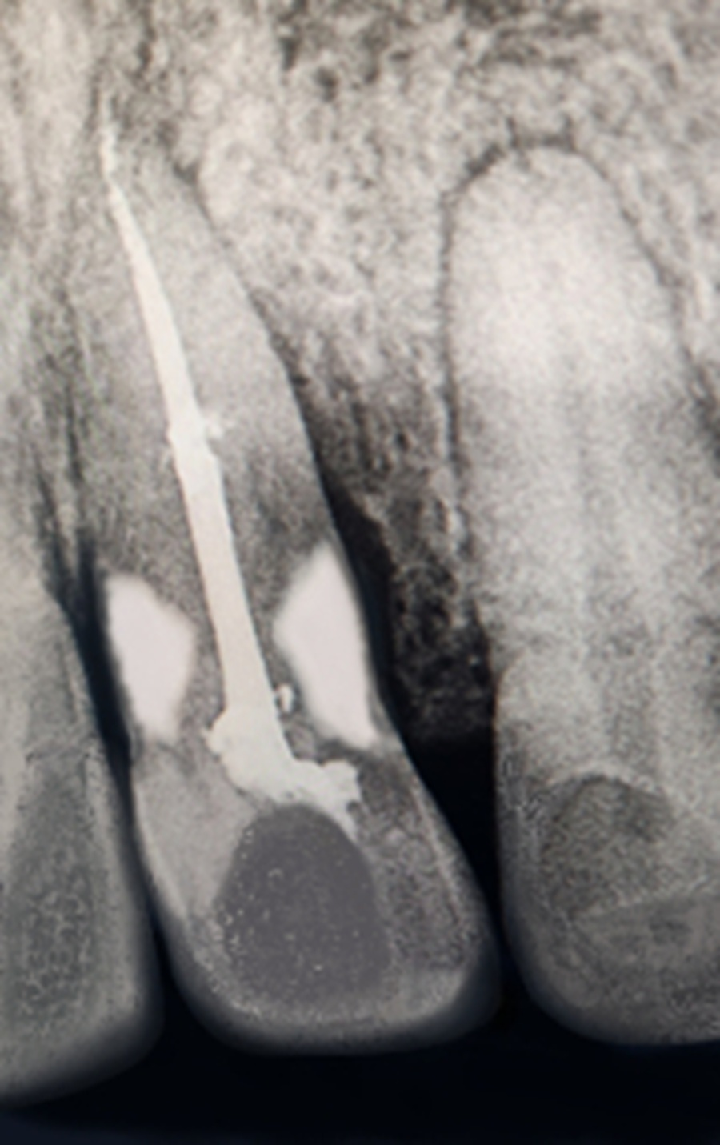

Figure 4.

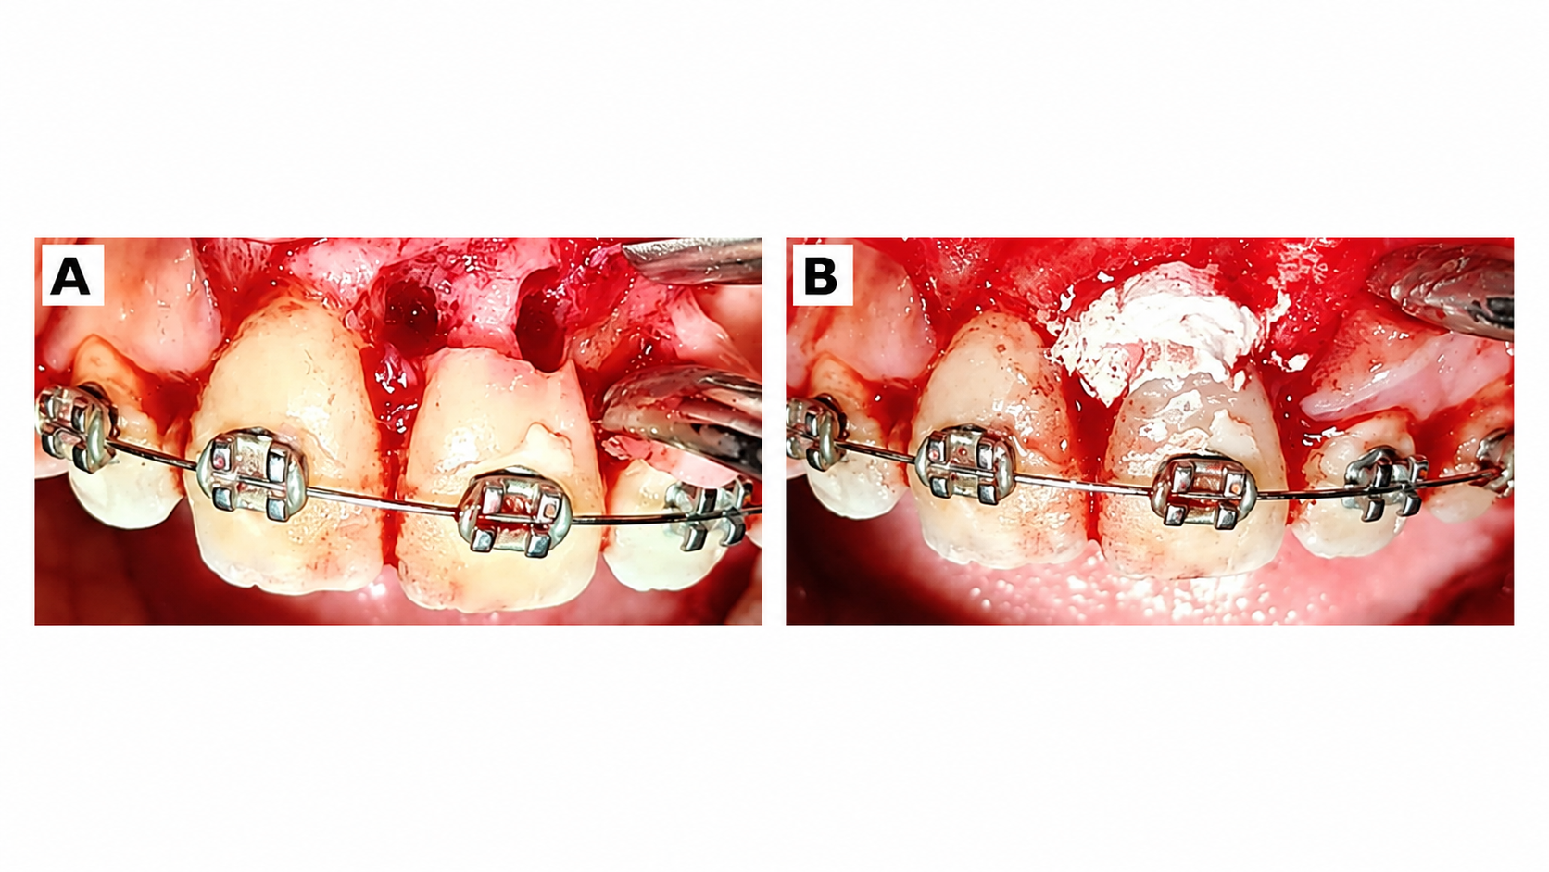

Figure 5.
